**BLUETOOTH CAR CONTROLLED WITH ANDROID APP**

**Bluetooth Shield for Arduino UNO**

The main reason for popularity of Arduino UNO platform is that it’s easy, cheap, open source and has a lot of resources on internet. So to start with we will use the most commonly used Bluetooth shield for Arduino HC-05. See the image below.

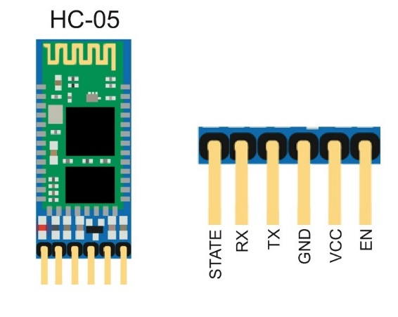

**Connect PINs as:**

|  |  |
| --- | --- |
| Arduino Pins | HC 05 Pins |
| VCC | 3.3V/5V (As on Module) |
| GND | GND |
| RX | TX |
| TX | RX |

**DESCRIPTION**

We just need to wire the module with Arduino as shown above. This module uses a protocol known as Serial Communication. It is a similar module as used in our USB’s. In this mode we send and receive data over two wires. You can see the RX and TX pins. In simple words:

**RX** means **Receiver**

**TX** means **Transfer**

So we connect these in opposite. The RX of Module is connected to TX of Arduino and TX of Module is connected to RX of Arduino. So Arduino Sends data using TX module and receives data using the RX module. So in this way the whole communication task place.

So as a whole, the Android phone connects to the Bluetooth module and sends data to it. Here Arduino is working in serial and reads that data in serial as well or in other words in series. We pass the data and use it for specific purpose

**Default Settings for HC - 05**

**The default settings for new modules are**

* Name = HC-05
* Password = 1234
* Baud rate in communication mode = 9600

(Android meets Arduino workshop)

**Circuit:**

In this implementation, we will connect the motor driver with the wheels and then connect the wires with Arduino. An external battery is connected in order to turn on the motor driver. HC-05 Bluetooth module has four pins. It’s RX and TX pins will be connected with TX and RX pins of Arduino respectively. HC-05 needs 5V to turn on which will be supplied from the Arduino.

# COMPONENTS:

* H-Bridge Motor Driver
* Arduino UNO
* HC-05
* Car set with wheels
* Breadboard
* Wires
* Android Mobile with App

Here is the schematic diagram of the project that you need to recreate.

